Bangladesh Medical Association (BMA)
List of Life Member-250
66. BMA Tangail Branch

Sl No | Voter No | Voter Details
1 | Voter No  LM-2000062  No Image | DR. MD. ABU ELIAS PRODHAN  F/Name:  M/Name:  BM & DC Reg. No:  NID:  Cell:  Address: UHC., Kaliakoir,Gazipur  Blood Group:  TRANSFERED to BMA Dhaka City  LM-1405543
2 | Voter No  LM-6600001  No Image | DR. A.T.M ABDUL HUQUE  F/Name:  M/Name:  BM & DC Reg. No:  NID:  Cell:  Address: Civil Surgeon Tangail  Blood Group:
3 | Voter No  LM-6600002  No Image | DR. MD. ABDUL KHALEQUE TALUKDER  F/Name:  M/Name:  BM & DC Reg. No:  NID:  Cell:  Address: Thana Para, Tangail  Blood Group:
4 | Voter No  LM-6600003  No Image | DR. MD. RASHIDUZZAMAN  F/Name:  M/Name:  BM & DC Reg. No:  NID:  Cell:  Address: TRANSFERED to BMA Manikgonj Br. LM-12  Blood Group:  TRANSFERED to BMA Dhaka City  LM-1405543
5 | Voter No  LM-6600004  No Image | DR. MD. SHAFIQUR RAHMAN  F/Name: Late Abu Sayed Mian  M/Name:  BM & DC Reg. No:  NID:  Cell:  Address: Victoria Road, Tangail  Blood Group:
6 | Voter No  LM-6600005  No Image | DR. MJD. HARUN-AR-RASHID  F/Name:  M/Name:  BM & DC Reg. No:  NID:  Cell:  Address:  Blood Group:  E X P I R E D
7 | Voter No  LM-6600006  No Image | DR. MD. RAFIQUL ISLAM  F/Name:  M/Name:  BM & DC Reg. No:  NID:  Cell:  Address: Sadar Thana Health Complex, Tangail  Blood Group:
8 | Voter No  LM-6600007  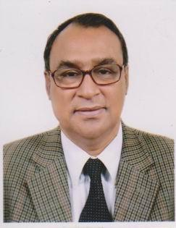 | DR. MD. ABDUR RAHMAN KHAN  F/Name: Md. Nayeb Ali Khan  M/Name:  BM & DC Reg. No:  NID:  Cell:  Address: East Adalat Para, Tangail  Blood Group:
9 | Voter No  LM-6600008 | DR. MD. NAZABAT HOSSAIN  F/Name:  M/Name:  BM & DC Reg. No:  NID:  Cell:  Address: Medical Officer General Hospital, Tangail  Blood Group:
10 | Voter No  LM-6600009  No Image | DR. MD. ABDUL HALIM  F/Name:  M/Name:  BM & DC Reg. No:  NID:  Cell:  Address: Medical Officer Bhadra Union Sub-Centre, Tangail  Blood Group:
11 | Voter No  LM-6600010 | DR. KHORSHID JAHAN  F/Name:  M/Name:  BM & DC Reg. No:  NID:  Cell:  Address: Medical Officer General Hospital, Tangail  Blood Group:
12 | Voter No  LM-6600011  No Image | DR. MD. RAFIQUL ISALM- MIA  F/Name:  M/Name:  BM & DC Reg. No:  NID:  Cell:  Address: Medical Officer Dharear Bari U.S.C, Tangail Sadar Thana, Tangail  Blood Group:
13 | Voter No  LM-6600012  No Image | DR. MST. MALEKA BANU  F/Name:  M/Name:  BM & DC Reg. No:  NID:  Cell:  Address: Medical Officer M.C.W.C, Tangail  Blood Group:
14 | Voter No  LM-6600013  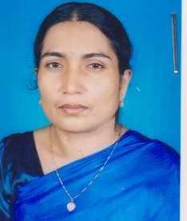 | DR. SUFIA BEGUM  F/Name:  M/Name:  BM & DC Reg. No:  NID:  Cell:  Address: Medical Officer (Deputed) Diabetic Association, Tangail  Blood Group:
15 | Voter No  LM-6600014 | DR. SYED EBNE SAYEED  F/Name:  M/Name:  BM & DC Reg. No:  NID:  Cell:  Address: Medical Officer M.S.C Ghatail, Tangail  Blood Group:
16 | Voter No  LM-6600015  No Image | DR. MD. FEROZA KHAN  F/Name:  M/Name:  BM & DC Reg. No:  NID:  Cell:  Address: Medical Officer Santosh Union Sub-Centre, Santosh, Tangail  Blood Group:
17 | Voter No  LM-6600016  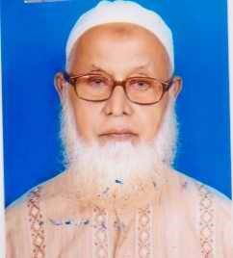 | DR. MD. ABU BAKAR SIDDIQUE  F/Name:  M/Name:  BM & DC Reg. No:  NID:  Cell:  Address: New Market, Tangail  Blood Group:
18 | Voter No  LM-6600017 | DR. MD. ABDUL BASIT  F/Name: Late Boshir Uddin Ahmed  M/Name:  BM & DC Reg. No:  NID:  Cell:  Address: Upazila Helth & Family Planning Officer, Sadar, Tangail.  Blood Group:
19 | Voter No  LM-6600018  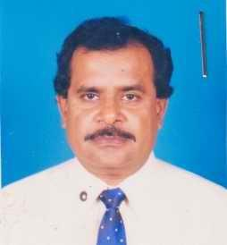 | DR. RATAN CHANDRA SAHA  F/Name:  M/Name:  BM & DC Reg. No:  NID:  Cell:  Address: Basalia U.S.C, Sadar Thana, Tangail  Blood Group:
20 | Voter No  LM-6600019  No Image | DR. BARUN CHANDRA PAUL  F/Name:  M/Name:  BM & DC Reg. No:  NID:  Cell:  Address: Medical Officer Shahjani USC, Nagarpur Health Complex, Tangail  Blood Group:
21 | Voter No  LM-6600020  No Image | DR. MOHAMMED ATIQUR RAHMAN  F/Name:  M/Name:  BM & DC Reg. No:  NID:  Cell:  Address: East Adalat Para, Victoria Road, Tangail  Blood Group:
22 | Voter No  LM-6600021  No Image | DR. MD. BADIUZZAMAN  F/Name:  M/Name:  BM & DC Reg. No:  NID:  Cell:  Address: Medical Officer Thana Health Complex, Ghatail, Tangail  Blood Group:
23 | Voter No  LM-6600022 | DR. MD. FARIDUZZAMAN  F/Name:  M/Name:  BM & DC Reg. No:  NID:  Cell:  Address: Medical Officer Thana Health Complex, Bauapur, Tangail  Blood Group:
24 | Voter No  LM-6600023  No Image | DR. MD. IQBAL HOSSAIN  F/Name:  M/Name:  BM & DC Reg. No:  NID:  Cell:  Address: TRANSFERED to BMA Dhaka City, LM-1401812  Blood Group:  TRANSFERED to BMA Dhaka City  LM-1405543
25 | Voter No  LM-6600024  No Image | DR. MAHFUZA AKTER  F/Name: Late Abdul Hakim Molla  M/Name:  BM & DC Reg. No:  NID:  Cell:  Address: General Hospital Tangail, Tangail  Blood Group:
26 | Voter No  LM-6600025  No Image | DR. MD. SHAMSUL ASHRAF KHAN  F/Name: Md. Shamsul Hoque Khan  M/Name:  BM & DC Reg. No:  NID:  Cell:  Address: Thana Health and Family Planning Officer Modhupur, Tangail  Blood Group:
27 | Voter No  LM-6600026  No Image | DR. SURESH CHANDRA SARKAR  F/Name: Ate Sakhi Charan Sarkar  M/Name:  BM & DC Reg. No:  NID:  Cell:  Address: Medical Officer Dhanbari, U.S.C, Modhupur, Tangail,  Blood Group:
28 | Voter No  LM-6600027  No Image | DR. KARUNA RANI KARMAKER  F/Name:  M/Name:  BM & DC Reg. No:  NID:  Cell:  Address: TRANSFERED to BMA Comilla Br. LM-1200087  Blood Group:  TRANSFERED to BMA Dhaka City  LM-1405543
29 | Voter No  LM-6600028  No Image | DR. A.K.M RAFIQUL ISLAM KHAN  F/Name:  M/Name:  BM & DC Reg. No:  NID:  Cell:  Address: TRANSFERED to BMA Netrokona Br. LM-4700007  Blood Group:  TRANSFERED to BMA Dhaka City  LM-1405543
30 | Voter No  LM-6600029  No Image | DR. JAYNUL ABEDIN TALUKDER  F/Name: Md. Mortuz Ali  M/Name:  BM & DC Reg. No:  NID:  Cell:  Address: Basail Health Complex, Tangail  Blood Group:
31 | Voter No  LM-6600030 | DR. MD. HARUN OR RASHID  F/Name: Md. Mazam Ali  M/Name:  BM & DC Reg. No:  NID:  Cell:  Address: Medical Officer Thana Health Complex, Basail, Tangail  Blood Group:
32 | Voter No  LM-6600031 | DR. MD. BELAYET HOSSAIN  F/Name: Late Sader Ali  M/Name:  BM & DC Reg. No:  NID:  Cell:  Address: Medical Officer General Hospital, Tangail  Blood Group:
33 | Voter No  LM-6600032  No Image | DR. MD. HAFIZUR RAHMAN  F/Name: Al Haz Md. Abdul Mazid Miah  M/Name:  BM & DC Reg. No:  NID:  Cell:  Address: Asstt. Surgion, Zellakara, Hospital, Tangail  Blood Group:
34 | Voter No  LM-6600033  No Image | DR. MD. ARIF KHAN  F/Name: Md. Fazlul Haque Khan  M/Name:  BM & DC Reg. No:  NID:  Cell:  Address: Titas Gas, T & D Co. Ltd. RDO, Tangail  Blood Group:
35 | Voter No  LM-6600034  No Image | DR. ABDUL MANNAN SIDDIQUI  F/Name:  M/Name:  BM & DC Reg. No:  NID:  Cell:  Address: Transfered to Noakhali LM-4900039  Blood Group:  TRANSFERED to BMA Dhaka City  LM-1405543
36 | Voter No  LM-6600035  No Image | DR. MOHAMMAD AMINUL ISLAM MIAN  F/Name:  M/Name:  BM & DC Reg. No:  NID:  Cell:  Address: Thana Health Complex, Ghatail,Tangail, Transfered to BMA Gopalganj LM- 2100069  Blood Group:  TRANSFERED to BMA Dhaka City  LM-1405543
37 | Voter No  LM-6600036  No Image | DR. SHAH ALI MIAH  F/Name: Late Md. Dewan Ali  M/Name:  BM & DC Reg. No:  NID:  Cell:  Address: Bat Tala, Tangail  Blood Group:
38 | Voter No  LM-6600037 | DR. MD. SHAMSUL HOQUE  F/Name: Al Haj Md. Abdur Rahman  M/Name:  BM & DC Reg. No:  NID:  Cell:  Address: Thana Health And Family Planning Officer Kalihati, Tangail  Blood Group:
39 | Voter No  LM-6600038  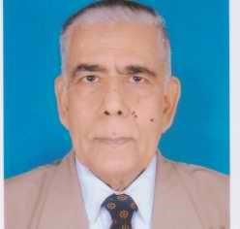 | DR. HARUN OR RASHID KHAN  F/Name: Late Abdul Wahed Khan  M/Name:  BM & DC Reg. No:  NID:  Cell:  Address: Adalat Para, Kali Bari Road, Tangail  Blood Group:
40 | Voter No  LM-6600039 | DR. MD. SADAR UDDIN  F/Name: Md. Muzaffar Ali  M/Name:  BM & DC Reg. No:  NID:  Cell:  Address: Kalihati, Health Complex, Tangail  Blood Group:
41 | Voter No  LM-6600040 | DR. MD. ANWAR HOSSAIN  F/Name: Md. Mayen Uddin  M/Name:  BM & DC Reg. No:  NID:  Cell:  Address: Thana Health Complex, Sakhipur, Tangail  Blood Group:
42 | Voter No  LM-6600041  No Image | DR. A. K. SALEH UDDIN AHAMMED  F/Name: Hafiz Uddin Ahammed  M/Name:  BM & DC Reg. No:  NID:  Cell:  Address: Jalchatra Hospital, P.O. Jalchatra, Modhupur, Tangail  Blood Group:
43 | Voter No  LM-6600042 | DR. MUHAMMAD MUJIBUR RAHMAN  F/Name: M. K. Mondal  M/Name:  BM & DC Reg. No:  NID:  Cell: 01713-200308  Address: Vill : Islampur, P.O. : Ukhariabari, Upazila : Dhanbari, Dist.-Tangail.  Blood Group:
44 | Voter No  LM-6600043  No Image | DR. AUNG KYA JAI MAUG  F/Name: Monngshe Maug  M/Name:  BM & DC Reg. No:  NID:  Cell:  Address: Jalchatra Hospital, P.O. Jalchatra, Modhupur, Tangail  Blood Group:
45 | Voter No  LM-6600044  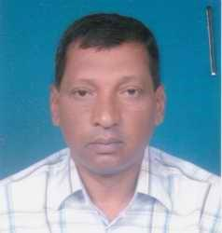 | DR. KAMRUL ISLAM KHAN YOUSUFZAI  F/Name: Shamsul Islam Khan Yousufzai  M/Name:  BM & DC Reg. No:  NID:  Cell:  Address: Sabalia, Tangail  Blood Group:
46 | Voter No  LM-6600045  No Image | DR. SHAMBHU NATH CHAKRAVORTY  F/Name: Late Tara Nath Chakravorty  M/Name:  BM & DC Reg. No:  NID:  Cell:  Address: Ellenga U.S.C, Kalihati, Tangail  Blood Group:
47 | Voter No  LM-6600046 | DR. MD. MOKHLESUR RAHMAN  F/Name: Nazir Hossain Ahmed  M/Name:  BM & DC Reg. No:  NID:  Cell:  Address: Disease, Contro, Civil Surgeon Office, Tangail  Blood Group:
48 | Voter No  LM-6600047 | DR. NUR MOHAMMAD  F/Name: Late Riaz Uddin  M/Name:  BM & DC Reg. No:  NID:  Cell:  Address:  Blood Group:
49 | Voter No  LM-6600048 | DR. MD. ABDUS SAMAD  F/Name: Late Sonaullah Miah  M/Name:  BM & DC Reg. No:  NID:  Cell:  Address: Kalihati THC, Tangail  Blood Group:
50 | Voter No  LM-6600049  No Image | DR. ASHRAFUL ISLAM  F/Name: Nurul Islam  M/Name:  BM & DC Reg. No:  NID:  Cell:  Address: Nahar Loge, Shimul Toli Road, Akur Takur, Tangail  Blood Group:
51 | Voter No  LM-6600050  No Image | DR. MD. NURUL ISLAM  F/Name: Haji Md. Sikander Ali Munshi  M/Name:  BM & DC Reg. No:  NID:  Cell:  Address: School Health Clinic, Tangail  Blood Group:
52 | Voter No  LM-6600051  No Image | DR. SALEHA KHATUN  F/Name:  M/Name:  BM & DC Reg. No:  NID:  Cell:  Address: TRANSFERED to BMA Mymenshing Br. LM-4100238  Blood Group:  TRANSFERED to BMA Dhaka City  LM-1405543
53 | Voter No  LM-6600052  No Image | DR. REZIA AKHTER BEGUM  F/Name: Abdul Hoque  M/Name:  BM & DC Reg. No:  NID:  Cell:  Address: Sontosh U.S.C, Tangail  Blood Group:
54 | Voter No  LM-6600053  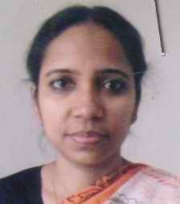 | DR. SHAHIDA BEGUM  F/Name: Late Md. Sharif Uddin Ahmed  M/Name:  BM & DC Reg. No:  NID:  Cell:  Address: Akur Takur, Bat Tola, Tangail  Blood Group:
55 | Voter No  LM-6600054 | DR. UPENDRA KUMAR DEY SARKER  F/Name: Late Debendra Kumar Dey Sarker  M/Name:  BM & DC Reg. No:  NID:  Cell:  Address: Radiologist General Hospital, Tangail  Blood Group:
56 | Voter No  LM-6600055  No Image | DR. BIMALENDU KUMAR SHAHA  F/Name: Purnendu Mohan Saha  M/Name:  BM & DC Reg. No:  NID:  Cell:  Address: Akur Takur Para, Tangail  Blood Group:
57 | Voter No  LM-6600056 | DR. KAMAL KRISHNA KARMOKER  F/Name:  M/Name:  BM & DC Reg. No:  NID:  Cell:  Address: Junior Consultant General Hospital, Tangail  Blood Group:
58 | Voter No  LM-6600057  No Image | DR. MD. SAIDUR RAHMAN BHUIYAN  F/Name: Habibur Rahman Bhuiyan  M/Name:  BM & DC Reg. No:  NID:  Cell:  Address: Thana Health And Family Planing Officer Gopalpur Tangail.  Blood Group:
59 | Voter No  LM-6600058 | DR. ABDUL KHALEQUE MIAH  F/Name: Late Abdul Mojid Miah  M/Name:  BM & DC Reg. No:  NID:  Cell:  Address: Vill. Satcetia, P.O- Kalihati, Tangail  Blood Group:
60 | Voter No  LM-6600059  No Image | DR. KH. MOSADDEQUE HOSSAIN  F/Name: Kh. Belayet Hossain  M/Name:  BM & DC Reg. No:  NID:  Cell:  Address: Vill. Biswasbetka, Tangail  Blood Group:
61 | Voter No  LM-6600060  No Image | DR. MD. LUTFOR RAHMAN KHAN  F/Name: Late Afsar Ali Khan  M/Name:  BM & DC Reg. No:  NID:  Cell:  Address: General Hospital, Tangail  Blood Group:
62 | Voter No  LM-6600061  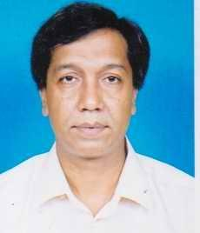 | DR. NAZRUL ISLAM TALUKDER  F/Name: Md. Easin Ali Talukder  M/Name:  BM & DC Reg. No:  NID:  Cell:  Address: Matri Kutir, Old Jail Road, Akur Takur Para, Tangail  Blood Group:
63 | Voter No  LM-6600062 | DR. MOZAMMEL HOSSAIN  F/Name: Nurul Hossain  M/Name:  BM & DC Reg. No:  NID:  Cell:  Address: General Hospital, Tangail  Blood Group:
64 | Voter No  LM-6600063  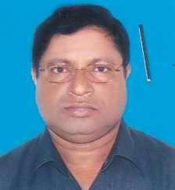 | DR. TAREK MD. SAFI  F/Name: Late Md. Sadek Ali  M/Name:  BM & DC Reg. No:  NID:  Cell:  Address: Pathology, General Hospital, Tangail  Blood Group:
65 | Voter No  LM-6600064 | DR. DULAL CHANDRA SAHA  F/Name: Dinesh Chandra Saha  M/Name:  BM & DC Reg. No:  NID:  Cell:  Address: East Adalat Para, Tangail  Blood Group:
66 | Voter No  LM-6600065  No Image | DR. MD. ASHRAF ALI  F/Name: Late A. Razzak  M/Name:  BM & DC Reg. No:  NID:  Cell:  Address: General Hospital Tangail.  Blood Group:
67 | Voter No  LM-6600066 | DR. MD. NURUL ISLAM SHAMIM  F/Name: Md. Reaz Uddin  M/Name:  BM & DC Reg. No:  NID:  Cell:  Address: General Hospital, Tangail  Blood Group:
68 | Voter No  LM-6600067  No Image | DR. MAHMUDUL HASAN  F/Name: Dr. Md. Abu Bakar Siddique  M/Name:  BM & DC Reg. No:  NID:  Cell:  Address: General Hospital, Manikgonj  Blood Group:
69 | Voter No  LM-6600068  No Image | DR. MD. AKMAL HOSSAIN  F/Name: Md. Sultan Ali  M/Name:  BM & DC Reg. No:  NID:  Cell:  Address: General Hospital, Tangail  Blood Group:
70 | Voter No  LM-6600069  No Image | DR. MD. MANIRUZZAMAN KHAN  F/Name:  M/Name:  BM & DC Reg. No:  NID:  Cell:  Address: Indoor Medical Officer, MMCH Maynmonshigh, Transfered to BMA Gopalganj LM-2100070  Blood Group:  TRANSFERED to BMA Dhaka City  LM-1405543
71 | Voter No  LM-6600070  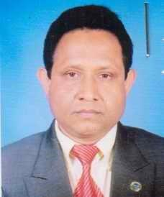 | DR. MD. NAZRUL ISLAM  F/Name: Al Haj Md. Joynal Abedin  M/Name:  BM & DC Reg. No:  NID:  Cell:  Address: Consultant, Eye, General Hospital, Tangail  Blood Group:
72 | Voter No  LM-6600071  No Image | DR. MD. SANAUL HAQUE  F/Name: Late Nurul Haque  M/Name:  BM & DC Reg. No:  NID:  Cell:  Address: Consultant, Paediatrcs General Hospital, Tangail  Blood Group:
73 | Voter No  LM-6600072 | DR. K.A.B.M. TAIFUL ALAM  F/Name: Md. Sakhawat Hossain Khand  M/Name:  BM & DC Reg. No:  NID:  Cell:  Address: Consultant, Surgery General Hospital, Tangail  Blood Group:
74 | Voter No  LM-6600073 | DR. MD. ABUSAMA  F/Name: Md. Daraz Ali  M/Name:  BM & DC Reg. No:  NID:  Cell:  Address: Police Hospital, Tangail  Blood Group:
75 | Voter No  LM-6600074  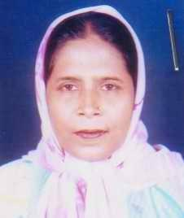 | DR. SHIRIN BEGUM  F/Name: Late Eabdul Bari  M/Name:  BM & DC Reg. No:  NID:  Cell:  Address: Clinic Mother, & Chil Welfare Centre, Tangail  Blood Group:
76 | Voter No  LM-6600075 | DR. MINATI RANI SAHA  F/Name: Late Umesh Chandra Saha  M/Name:  BM & DC Reg. No:  NID:  Cell:  Address: Purba Adalat Para, Tangail  Blood Group:
77 | Voter No  LM-6600076  No Image | DR. SAIFUL ISLAM  F/Name: Md. Abu Bakar Siddque  M/Name:  BM & DC Reg. No:  NID:  Cell:  Address: Thana Para, Tangail  Blood Group:
78 | Voter No  LM-6600077  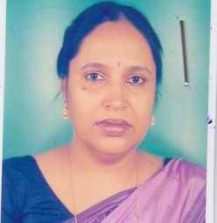 | DR. DEBY BHADRA  F/Name: Late Girija Prasad Bhadra  M/Name:  BM & DC Reg. No:  NID:  Cell:  Address: East Adalat Para, Tangail  Blood Group:
79 | Voter No  LM-6600078  No Image | DR. ASM AMJAD HOSSAIN  F/Name: S M Akhtaruzzaman  M/Name: Nilufa Akhter  BM & DC Reg. No: 29197  NID: 2695051176265  Cell: 01719431219  Address: Flat# 703, Bldg# 2, Nam Garden Govt Officer`s Quarter, Mirpur-13, Dhaka.  Blood Group: AB+
80 | Voter No  LM-6600079  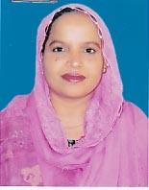 | DR. AKHTER ZAHAN  F/Name: Md. Abul Hossain Talukder  M/Name:  BM & DC Reg. No:  NID:  Cell:  Address: Asiya Manzil, 249, Jail Road, Tangail  Blood Group:
81 | Voter No  LM-6600080 | DR. MD. ABDUL JALIL  F/Name: Late Md. Sonamuddin Molla  M/Name:  BM & DC Reg. No:  NID:  Cell:  Address: Maternity Hospital, Tangail  Blood Group:
82 | Voter No  LM-6600081  No Image | DR. A.K.M ABDUL HAMID  F/Name: A.S. Anwar Hossain  M/Name:  BM & DC Reg. No:  NID:  Cell:  Address: Patuli Para, Kagmari College Road, Tangail  Blood Group:
83 | Voter No  LM-6600082  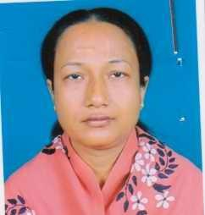 | DR. JESMIN ZUBAIR  F/Name: Md. Abdul Jobber  M/Name:  BM & DC Reg. No:  NID:  Cell:  Address: 5, No Medical Officers Quarter, Tangail  Blood Group:
84 | Voter No  LM-6600083  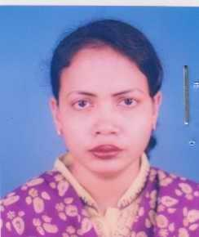 | DR. SHARIF MASUMA ISMAT  F/Name: Mr. Md. Ismat Ali Sharif  M/Name:  BM & DC Reg. No:  NID:  Cell:  Address: Asstt. Regisstrar Gynae General Hospital, Tangail  Blood Group:
85 | Voter No  LM-6600084  No Image | DR. MOHAMMAD ABDULLAH AL MASUD  F/Name: Md. Hafiz Uddin  M/Name:  BM & DC Reg. No:  NID:  Cell:  Address: Basa No- 15, Main Road, Perdigulia, P.S. Tangail, Tangail  Blood Group:
86 | Voter No  LM-6600085  No Image | DR. PUTUL ROY  F/Name: Late Gouri Sanker Roy  M/Name:  BM & DC Reg. No:  NID:  Cell:  Address: Assisttant Registrar Gynae & OBS, Jamalpur General Hospital, Tangail  Blood Group:
87 | Voter No  LM-6600086 | DR. TAPAN KUMAR SAHA  F/Name:  M/Name:  BM & DC Reg. No:  NID:  Cell:  Address: Junior Consultant ( Current Charge) Pathology Department General Hospital, Tangail.  Blood Group:
88 | Voter No  LM-6600087 | DR. MD. FARHAD ALI KHAN  F/Name: Md. Niamot Ali Khan  M/Name: Syeda Ayesha Khanom  BM & DC Reg. No: 20981  NID: 9329514303845  Cell: 01712122132  Address: House no-2, Block-E, Green Road, East Adalat Para, Tangail  Blood Group: B+
89 | Voter No  LM-6600088 | DR. TANZINA LATIF  F/Name: Abdul Latif  M/Name: Begum Fatema Akhtar  BM & DC Reg. No: 22978  NID: 9329514304761  Cell: 01711158798  Address: Junior Consultant (Gynae & Obs) 250 Beded Ganeral Hospital, Tangail  Blood Group: AB+
90 | Voter No  LM-6600089 | DR. REHANA PERVIN  F/Name: Late. Tafir Uddin  M/Name: Late. Shamsunnahar  BM & DC Reg. No: 28208  NID: 2691650161875  Cell: 01712765850  Address: Consultant Quater, Sadar Hospital, Tangail  Blood Group: O+
91 | Voter No  LM-6600090 | DR. TASLIMA BEGUM  F/Name: M. Siddiqul Mawla  M/Name: Firoza Begum  BM & DC Reg. No: 28530  NID: 2611038747607  Cell: 01713161502  Address: Junior Consultant (Gynae & Obs), Upazila Health Complex, Modhupur, Tangail  Blood Group: O+
92 | Voter No  LM-6600091 | DR. SHIRIN AKHTER  F/Name: Md. Abu Taleb  M/Name: Late. Farida Begum  BM & DC Reg. No: 21667  NID:  Cell: 01711986943  Address: Rokeya Villa, Registry Para, Tangail  Blood Group: O+
93 | Voter No  LM-6600092 | DR. JAKEYA RASHID  F/Name: Md. (late) Abdur Rashid  M/Name: Mrs. Fatema Khatun  BM & DC Reg. No: 30734  NID: 2696352208690  Cell: 01714404033  Address: House no- 02, Block-E, Green Road, East Adalat Para, Tangail  Blood Group: B+
94 | Voter No  LM-6600093 | DR. ASHIM KUMAR NANDI  F/Name: Late. Kulendra Chandra Nandi  M/Name: Chamily Shurovi Nandi  BM & DC Reg. No: 16122  NID: 6125210181842  Cell: 01711323538  Address: Consultant (Skin & VD), General Hospital, Tangail  Blood Group: B+
95 | Voter No  LM-6600094 | DR. KHAN MD. SAYEDUZZAMAN  F/Name: Khan Abdur Rahim  M/Name: Late. Hamida Begum  BM & DC Reg. No: 15952  NID: 9329518333834  Cell: 01726243854  Address: Medicine Department, Cons. Med. (Jr.), General Hospital, Tangail  Blood Group: A+
96 | Voter No  LM-6600095 | DR. SHEIKH ANISUL HAQUE  F/Name: Late Eakub Ali Sheikh  M/Name: Mrs. Asinmonnessa  BM & DC Reg. No: 14631  NID: 2690815048199  Cell: 01711140385  Address: Jr. Consultant (Paediatrics) General Hospital, Tangail  Blood Group: B+
97 | Voter No  LM-6600096 | DR. ARUN CHANDRA ROY  F/Name: Nependra Lal Arja  M/Name: Golap Rani  BM & DC Reg. No: 40313  NID: 9314783467241  Cell: 01713580232  Address: Dhaka Hospital & Diagastic Centre Kalihati Bustand, Kalihati, Tangail  Blood Group: B+
98 | Voter No  LM-6600097 | DR. MD. ABDUL MATIN  F/Name: Late. Abdul Baset  M/Name: Asia Khatun  BM & DC Reg. No: 11747  NID: 9329518329706  Cell: 01715815427  Address: Vill: Sabalia, Thana & District: Tangail  Blood Group: B+
99 | Voter No  LM-6600098 | DR. NARAYAN CH. SAHA  F/Name: Mohan Bashi Saha  M/Name: Bedana Bala Saha  BM & DC Reg. No: 26446  NID: 9329501131630  Cell: 01715470718  Address: Lake Corner, Battola, Zilla Sadar Road, Tangail  Blood Group: O+
100 | Voter No  LM-6600099 | DR. SYED MONIRUL ISLAM  F/Name: Late. Nazrul Islam  M/Name: Mrs. Rokeya Begum  BM & DC Reg. No: 28929  NID: 2691650161874  Cell: 01711069256  Address: Consultant Quarter, Ground Floor, General Hospital, Tangail  Blood Group: B+
101 | Voter No  LM-6600100 | DR. MD. JOYNAL ABEDIN  F/Name: Late. Md. Nazir Hossain  M/Name: Jayeda Begum  BM & DC Reg. No: 34970  NID: 9329518328957  Cell: 01712695850  Address: Upattaka, New Bus Terminal, Dewla, Tangail  Blood Group: O+
102 | Voter No  LM-6600101 | DR. MD. NURUL HUDA  F/Name: Alhaj Md. Osman Goni  M/Name: Late. Amina Begum  BM & DC Reg. No: 14039  NID: 9324707237882  Cell: 01712288469  Address: Resident Medical Officer (R.M.O.) Upazila Health Complex, Madhupur  Blood Group: AB+
103 | Voter No  LM-6600102 | DR. MD. SHAHIDULLAH KAISER  F/Name: Muhammod Ear Ullah  M/Name: Mrs. Rahima Akter  BM & DC Reg. No: 23038  NID:  Cell: 01916581544  Address: Room no-607, Block- A, BSMMU, Shahbagh, Dhaka  Blood Group: A+
104 | Voter No  LM-6600103  No Image | DR. UTTAM KUMAR BOSAK  F/Name:  M/Name:  BM & DC Reg. No:  NID:  Cell:  Address: Upasatha Centre, Dhanbari, Tangail., (T.F. Dinajpur, LM-115).  Blood Group:
105 | Voter No  LM-6600104  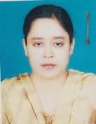 | DR. ASMA AKTHER  F/Name: Md. Abdul Motaleb  M/Name: Mrs. Anowara Begum  BM & DC Reg. No: 33872  NID: 6125216664324  Cell: 01916581545  Address: Sadar Hospital Quarter, Tangail  Blood Group: A+
106 | Voter No  LM-6600105 | DR. FARID AHMED  F/Name: Md. Chan Mahmud  M/Name: Mrs. Hasina Mahmud  BM & DC Reg. No: 29984  NID: 9310971373257  Cell: 01711016730  Address: Consultant Surgery- General Hospital Tangail  Blood Group: O+
107 | Voter No  LM-6600106 | DR. SONIA FERDOUSY  F/Name: Muhammad Rashiduzzaman  M/Name: Sufia Begum  BM & DC Reg. No: 48531  NID: 9329506256100  Cell: 01916688885  Address: Zaker Mahal, Pardighulia, Tangail  Blood Group: A+
108 | Voter No  LM-6600107 | DR. A. M. SHAFIQUR RAHMAN KHAN LITON  F/Name: A. M. Hafizur Rahman Khan  M/Name: Late. Shamsun Nahar Khan  BM & DC Reg. No: 32387  NID: 9329514302652  Cell: 01714261126  Address: East Adalat Para, Fire Service Road, Tangail  Blood Group: B+
109 | Voter No  LM-6600108 | DR. SHAFIQUL ISLAM  F/Name: Md. Wazed Ali  M/Name: Mrs. Hasna Bhanu  BM & DC Reg. No: 34063  NID: 9329514306028  Cell: 01712527654  Address: Thana Para, Tangail  Blood Group: A+
110 | Voter No  LM-6600109  No Image | DR.CHOUDHURY MATIUZZAMAN SIDDIQUE  F/Name: Late Naimuddin Ahmed Choudhury  M/Name: Mohiba Khatun  BM & DC Reg. No: 9625  NID:  Cell:  Address: Mo Fpab, Akurtakur Para, Tangail  Blood Group:
111 | Voter No  LM-6600110 | DR. MD. MOFAZZAL HOSSAIN  F/Name: Late. Kabir Miah  M/Name: Late. Sakhina Begum  BM & DC Reg. No: 10635  NID: 9329517323356  Cell: 01711936016  Address: No- 8 Registry Para, Tangail.  Blood Group: AB+
112 | Voter No  LM-6600111 | DR. MUHAMMAD MUNIRUZZAMAN CHOWDHURY  F/Name: Late. Shamsuzzaman Chowdhury  M/Name: Laila Zaman Chowdhury  BM & DC Reg. No: 25649  NID: 2694807982756  Cell: 01711443723  Address: U.H.C Kalihati, Tangail.  Blood Group: A+
113 | Voter No  LM-6600112 | DR. MD ABU HANIF  F/Name: Abdul Quddus  M/Name: Hamida Begum  BM & DC Reg. No: 31184  NID:  Cell: 01711908399  Address: Vill: Karatia Charpara, P.O: Karatia, P.S: & Dist; Tangail  Blood Group: O+
114 | Voter No  LM-6600113 | DR. MOHAMMAD JAHANGIR ALAM  F/Name: Md. Amir Hamza Mia  M/Name: Mrs. Hamida Begum  BM & DC Reg. No: 31853  NID: 9319590516230  Cell: 01711308003  Address: SSS Eye Hospital, Sabalia, Tangail.  Blood Group: B+
115 | Voter No  LM-6600114 | DR MD. AZHARUL ISLAM  F/Name: Late. Moyzuddin Ahmed  M/Name: Late. Rezia Ahmed  BM & DC Reg. No: 8898  NID:  Cell: 01715365714  Address: Vill: GoshaiBari, Kumulli, Tangail.  Blood Group: A+
116 | Voter No  LM-6600115  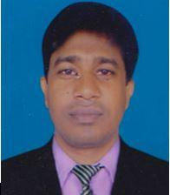 | DR. ABDL HYEE  F/Name: Md. Bahaz Uddin  M/Name: Mrs. Asiya Parvin  BM & DC Reg. No: 33678  NID:  Cell: 01715024343  Address: Rokeya Clinic, Karatia, Tangail  Blood Group:
117 | Voter No  LM-6600116 | DR. MOHAMMAD ZILLUR RAHMAN  F/Name: Mohammad Nazlar Rahman  M/Name: Jahanara Rahman  BM & DC Reg. No: 27834  NID: 6125214204862  Cell: 01552381566  Address: Flat-5D, Junior Consultant Quarter, 250 Beded General Hospital , Tangail.  Blood Group: O+
118 | Voter No  LM-6600117 | DR. M. A. JALIL  F/Name: Late. Sultan Mondal  M/Name: Mst. Rezia Begum  BM & DC Reg. No: 22854  NID: 9326603053722  Cell: 01747501024  Address: Hanufa Memorial Eye Hospital, Mirzapar,Tangail.  Blood Group: A+
119 | Voter No  LM-6600118 | DR. JAYASHREE BHOWMIK  F/Name: Late. Dukhiram Rajbansi  M/Name: Late. Surodhani Rajbansi  BM & DC Reg. No: 19440  NID: 9326603053347  Cell: 01815406555  Address: Ashkabar Bhaban,Mirzapur, Tangial.  Blood Group: n_a
120 | Voter No  LM-6600119 | DR. TAPAS KANTI BHOWMIK  F/Name: Late. Sukhamoy Bhowmik  M/Name: Sunity Bhowmik  BM & DC Reg. No: 17675  NID: 9326603053355  Cell: 01817567283  Address: Ashkabar Bhaban Mirzapur, Tangail.  Blood Group: B+
121 | Voter No  LM-6600120  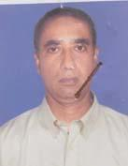 | DR. RAFIUL ALAM KHAN  F/Name: Late. Abdul Kader Khan  M/Name: Mst. Laily Begum  BM & DC Reg. No: 11016  NID: 2611038714456  Cell: 01715119593  Address: Assistant Professor, Microbiology Dept, Coxs Bazar Medical College, Coxs Bazar.  Blood Group: B+
122 | Voter No  LM-6600121 | DR. A.K.M ZAYEDUL HAQUE  F/Name: Late. Md. Kashem Ali  M/Name: Begum Gulnahar Arjuman Khanam  BM & DC Reg. No: 25172  NID: 2690243834741  Cell: 01716474497  Address: Junior Consultant Quarter, Flat No-5 General Hospital , Tangail.  Blood Group: B+
123 | Voter No  LM-6600122 | DR. SABRINA ISLAM  F/Name: Md. Shafiqul Islam  M/Name: Shazeda Parvin  BM & DC Reg. No: 56492  NID: 8198510364912  Cell: 01723099197  Address: Thana Para, Tangail.  Blood Group: O+
124 | Voter No  LM-6600123  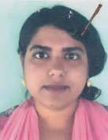 | DR. NAZMIN JAHAN SULTANA  F/Name: A.k.m. Nur Nabi  M/Name: Aysha Sultana  BM & DC Reg. No: 52530  NID: 8524904042884  Cell: 01738754494  Address: Vill: Nandanpur Bazar, P.O & Thana: Gopalpur, Dist: Tangail.  Blood Group: A+
125 | Voter No  LM-6600124  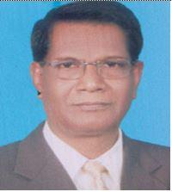 | DR. MD. ABDUS SAMAD SARKER  F/Name: Late Alhaj Intaz Ali  M/Name: Late Nesaran Nesa Bibi  BM & DC Reg. No: A 19490  NID:  Cell: 01718481210  Address: Dolphin Diagnostic & Consultation Centre, Pourashava Rd, Dhanbari, Tangail  Blood Group:
126 | Voter No  LM-6600125 | DR. MD. SHAH ALAM TALUKDER  F/Name: Late. Insan Ali Talukder  M/Name: Late. Sufia Begum  BM & DC Reg. No: 13601  NID: 9312869574516  Cell: 01711124954  Address: Upazilla Health And Family Planning Officer Ghatail, Tangail.  Blood Group: O+
127 | Voter No  LM-6600126 | DR. MD. ASHIQUR RAHMAN RASEL  F/Name: Dr. Nur Mohammad  M/Name: Salma Begum  BM & DC Reg. No: 58538  NID: 9329503205353  Cell: 01716012564  Address: House No: 36 Block-D, West Akur Takur Para, Tangail.  Blood Group: B+
128 | Voter No  LM-6600127 | DR. MOHAMMAD NAJRUL ISLAM  F/Name: Md. Yad Ali Miah  M/Name: Begum Noorjahan  BM & DC Reg. No: 44785  NID: 9312341626856  Cell: 01728641862  Address: Course (MSENT)-BSMMU Shahbag Dhaka-1000.  Blood Group: B+
129 | Voter No  LM-6600128 | DR. KHAIRUN NAHAR  F/Name: Md. Khalilur Rahman Bhuiya  M/Name: Fazilatun Nesa  BM & DC Reg. No: 52112  NID: 9322807540782  Cell: 01687096437  Address: Akeer Takur Para, Tangail  Blood Group: B+
130 | Voter No  LM-6600129 | DR. MOHAMMAD SHAMIM AL MAMUN  F/Name: Mohammad Jamal Uddin  M/Name: Hazera Khatun  BM & DC Reg. No: 40373  NID: 9310971373141  Cell: 01714091096  Address: Room no. 605, /don-Planning, Dahs Mohakhali, Dhaka-1212  Blood Group: A+
131 | Voter No  LM-6600130 | DR. ABUL HAYAT MANIK  F/Name: Md. Jasim Uddin  M/Name: Mrs. Hosneara Begum  BM & DC Reg. No: 44334  NID: 2695433105261  Cell: 01711372914  Address: Flat c-5, sky View Eden, 128, Shantinagar, Dhaka  Blood Group: A+
132 | Voter No  LM-6600131 | DR. SAMARENDRA CHANDRA PANDIT  F/Name: Narendra Chandra Pandit  M/Name: Pushpa Rani Debi  BM & DC Reg. No: 44980  NID: 2697557395344  Cell: 01719263018  Address: Vill-Kushtia, Post+Thana-Kalihati, Tangail  Blood Group: O+
133 | Voter No  LM-6600132 | DR. KAMRUN NAHAR  F/Name: Md. Abdul Kuddus Sarker  M/Name: Ismat Ara Begum  BM & DC Reg. No: 61685  NID: 19889311967000029  Cell: 01731187917  Address: Polash Toli Road, Tangail  Blood Group: O+
134 | Voter No  LM-6600133 | DR. AZMARY KHAN  F/Name: Md. Azmal Hossain Khan  M/Name: Rashida Akter  BM & DC Reg. No: 68451  NID: 9329504245989  Cell: 01553205345  Address: Vill-Beradoma, Post-Tangail, Thana-Tangail, Dist-Tangail  Blood Group: AB+
135 | Voter No  LM-6600134  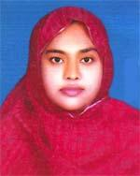 | DR. ASRAFI KHAN  F/Name: Md. Azmal Hossain Khan  M/Name: Rashida Aktar  BM & DC Reg. No: 58835  NID: 9329504245988  Cell: 01712461618  Address: House No.-1, Road No.-1, Islambag, Beradona, Tangail  Blood Group: B+
136 | Voter No  LM-6600135 | DR. MD. ENAMUL HOQUE  F/Name: Late Dr. A. K. M. Nurul Huq  M/Name: Mrs. Hamida Khatoon  BM & DC Reg. No: 19135  NID: 9329517322549  Cell: 01715943738  Address: Diabetic Association, Sabalia, Sadar, Tangail  Blood Group: O+
137 | Voter No  LM-6600136  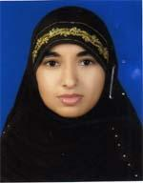 | DR. SHAMIMA NASRIN  F/Name: Abdur Rahman Miah  M/Name: Begum Rokeya  BM & DC Reg. No: 44429  NID: 9329516316792  Cell: 01740797344  Address: Akur Takur Muslim Para, Tangail  Blood Group: B+
138 | Voter No  LM-6600137 | DR. MUHAMMAD ABU IDRIS  F/Name: Muhammad Abu Yusuf  M/Name: Musammat Asia Khatun  BM & DC Reg. No: 42686  NID: 9328503973392  Cell: 01919364027  Address: M. O; UHC-Basail, Tangail  Blood Group: AB+
139 | Voter No  LM-6600138 | DR. A. F. M. ARSHEDI SATTAR  F/Name: Late Md. Abdus Sattar  M/Name: Mrs. Rokeya Begum  BM & DC Reg. No: 26943  NID: 2619551166164  Cell: 01611109942  Address: East Adalot Para, Tangail  Blood Group: B+
140 | Voter No  LM-6600139  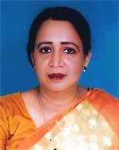 | DR. MAMTAJ BEGUM  F/Name: Late Md. Daraj Ali  M/Name: Mrs. Hamida Begum  BM & DC Reg. No: 17267  NID: 9329516318058  Cell: 01715332958  Address: Dr, Meuty Begum, M. C. W. C. Tamapara, Tangail  Blood Group: B+
141 | Voter No  LM-6600140  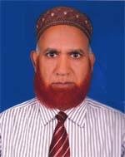 | DR. MD. ABDUL ALIM  F/Name: Late Abdul Gaffur Dewan  M/Name: Late Tarifun Nesa  BM & DC Reg. No: 20040  NID: 9329517322815  Cell: 01711782355  Address: MCWC, Tangail  Blood Group: A+
142 | Voter No  LM-6600141 | DR. MD. MAJNU MIAH  F/Name: Late Abdul Awal  M/Name: Late Rabeya Khatun  BM & DC Reg. No: 20866  NID: 2699501905865  Cell: 01711352199  Address: Upazilla Health Complex, Delduar, Tangail  Blood Group: A+
143 | Voter No  LM-6600142 | DR. HAZERA SULTANA  F/Name: Mohammad Abdul Hamid  M/Name: Mamtaz Begum  BM & DC Reg. No: 46236  NID: 9329517325368  Cell: 01818738842  Address: 2nd Floor, SSS Eye Hospital Diabetic hospital road, Tangail  Blood Group: B+
144 | Voter No  LM-6600143  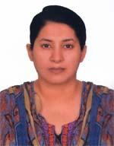 | DR. AKHLIMA KHAN (LOREN)  F/Name: Liakat Ali Khan  M/Name: Hosneara Khan  BM & DC Reg. No: 42602  NID: 9329517325366  Cell: 01715943202  Address: SSS Hospital, Sabalia, Tangail  Blood Group: A+
145 | Voter No  LM-6600144 | DR. MD. RAFIQUL ISLAM  F/Name: Late Md. Mortuz Ali  M/Name: Rokeya Begam  BM & DC Reg. No: 23885  NID: 6125203118388  Cell: 01712051799  Address: Medical officer MCH&FP. Sakhipur, Tangail  Blood Group: B+
146 | Voter No  LM-6600145  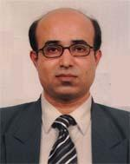 | DR. MD. SUHEL AL MUJAHID REZA  F/Name: Md. Baharul Islam  M/Name: Shahida Begum  BM & DC Reg. No: 28082  NID: 19709321904372051  Cell: 01735447735  Address: Tangail Medical College, Tangail  Blood Group: A+
147 | Voter No  LM-6600146  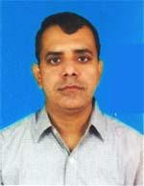 | DR. MD. ANISUR RAHMAN  F/Name: Late Taim Uddin Miah  M/Name: Basatan Nesa  BM & DC Reg. No: 25072  NID: 9314758440085  Cell: 01715304218  Address: Tangail Medical College, Tangail  Blood Group: A+
148 | Voter No  LM-6600147  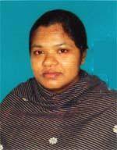 | DR. JAHIDA BEGUM  F/Name: S. M. Jator Ali  M/Name: Monowara Jator  BM & DC Reg. No: 47608  NID: 62125214284184  Cell: 01718739813  Address: House-4, Premio Plasa, Zilla Sadar Road, 307 Tola, Tangail  Blood Group: O+
149 | Voter No  LM-6600148 | DR. MD. RAHAT CHOWDHURY  F/Name: S. M. Eunus Chowdhury  M/Name: Mst. Bilkitch Sultana  BM & DC Reg. No: 56375  NID: 4329502654940  Cell: 01719476101  Address: House-48, Road-2, Block-D, College Para ,Tangail  Blood Group: A+
150 | Voter No  LM-6600149  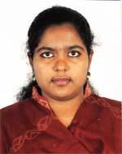 | DR. SHARMIN AKTER  F/Name: Md. Shariful Islam  M/Name: Kh. Rina Akter  BM & DC Reg. No: 60210  NID: 9329512290468  Cell: 01714499667  Address: Tangail  Blood Group: O+
151 | Voter No  LM-6600150  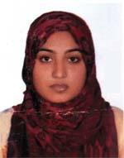 | DR. SAIMA AKTER  F/Name: A. K. Masum  M/Name: Mrs. Beauty  BM & DC Reg. No: 59728  NID: 6125214204922  Cell: 01710597765  Address: Block-E, House No # 1, Green Road, Dhanmondi, Tangail  Blood Group: O+
152 | Voter No  LM-6600151 | DR. BIPLOB CHANDRA DAS  F/Name: Nitai Chandra Das  M/Name: Jugmaya Das  BM & DC Reg. No: 29183  NID: 5329504218832  Cell: 01711274203  Address: Fatema Clinic Tangail  Blood Group: A+
153 | Voter No  LM-6600152  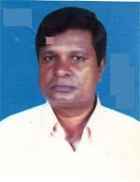 | DR. MD. ALI KHAN  F/Name: Md. Nazar Ali Khan  M/Name: Mrs. Aziron Nessa  BM & DC Reg. No: 15906  NID: 9310971335300  Cell: 01712568687  Address: Professor & Pricipal, Tangail Medical College, Tangail  Blood Group: B+
154 | Voter No  LM-6600153 | DR. MD. ASSADUZZAMAN LITON  F/Name: Md. Ibrahim Khalil  M/Name: Anwara Begum  BM & DC Reg. No: 51466  NID: 9329516316889  Cell: 01748975226  Address: Room-E-7, Doctor\'s Dormitory, Dhaka Medical Hospital, Dhaka  Blood Group: A+
155 | Voter No  LM-6600154  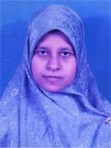 | DR. MAHBUBA NASREEN SONIA  F/Name: Md. Mokaddes Ali Miah  M/Name: Most. Nasima Khatun  BM & DC Reg. No: 60420  NID: 6125214204916  Cell: 01936280583  Address: Vill-Kaijury, Post-Kaijury, Thana-Delduar, Dist-Tangail  Blood Group: A+
156 | Voter No  LM-6600155  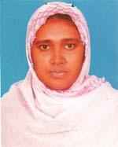 | DR. SONYA SHARMIN  F/Name: Selim Hossain  M/Name: Jabida Begum  BM & DC Reg. No: 52823  NID: 9329506252465  Cell: 01914462418  Address: Jahan Monjil, Per Dighulia, Tangail  Blood Group: B+
157 | Voter No  LM-6600156 | DR. RAMENDRA NATH SAHA  F/Name: Nripendra Narayan Saha  M/Name: Niripoma Saha  BM & DC Reg. No: 19152  NID: 9326602056306  Cell: 01819663607  Address: Sayed Tower, Flat No.4A, Mirzapur Bazar, Mizapur, Tangail  Blood Group: AB+
158 | Voter No  LM-6600157  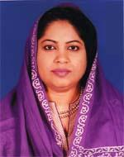 | DR. NAZMA KHALIL  F/Name: Khalilur Rahman  M/Name: Kohinoor Begum  BM & DC Reg. No: 36232  NID: 19789329518000004  Cell: 01731085220  Address: Tangail Medical College Quater Tangail.  Blood Group: O+
159 | Voter No  LM-6600158 | DR.FATEHA YASMIN ANTARA  F/Name: Md. Hamidur Rahman  M/Name: Farida Yasmin  BM & DC Reg. No: 56546  NID: 9329507259557  Cell: 01721452912  Address: Flat No.-120, Building -02, Charmvilla, 169, Green Road, Dhaka  Blood Group: B+
160 | Voter No  LM-6600159 | DR. SHAH MUHAMMAD MASUDUZZAMAN  F/Name: Md. Wazed Ali  M/Name: Mst. Nazma Begum  BM & DC Reg. No: 27509  NID: 9310947234948  Cell: 01711181939  Address: Junior Consultant (Paed) , 250 Bedded General Hospital, Tangail  Blood Group: B+
161 | Voter No  LM-6600160 | DR. NAZIA AKTHER AZIM  F/Name: A. F. M. Nurul Azim  M/Name: Jesmin Sultana  BM & DC Reg. No: 54359  NID: 2694261651444  Cell: 01712828618  Address: Doctor\'s Quatar, General Hospital, Tangail  Blood Group: A+
162 | Voter No  LM-6600161  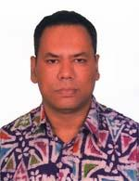 | DR. MD. RAFIQUL ALAM TALUKDER  F/Name: Md. Abdur Rashid Talukder  M/Name: Shahera Banu  BM & DC Reg. No: 28702  NID: 1970269426165144  Cell: 01711784276  Address: Doctor\'s Quatar, General Hospital, Tangail  Blood Group: B+
163 | Voter No  LM-6600162 | DR. MD. NURUL AMIN MIAH  F/Name: Md. Khoda Baksh Miah  M/Name: Suzia Begum  BM & DC Reg. No: 23911  NID: 2694263701301  Cell: 01711538978  Address: Associate Professor, Medicine Tangail Medical College, Tangail  Blood Group: O+
164 | Voter No  LM-6600163 | DR. NASRIN SULTANA  F/Name: Md. Nazim Uddin  M/Name: Shajeda Begum  BM & DC Reg. No: 41346  NID: 2617218964582  Cell: 01812333888  Address: MO. Pathology Dept. TMCH, Tangail  Blood Group: B+
165 | Voter No  LM-6600164 | DR. SUZAUDDIN TALUKDER  F/Name: Shamsuddin Talukder  M/Name: Hasina Talukder  BM & DC Reg. No: 44034  NID: 3693622276761  Cell: 01740797357  Address: Akur Takur Muslimpara, Tangail  Blood Group: O+
166 | Voter No  LM-6600165 | DR. MOHAMMAD KHALID HOSSAIN  F/Name: Mohammad Akbar Hossain  M/Name: Most. Sakhina Begum  BM & DC Reg. No: 34732  NID: 9310935222276  Cell: 01712230075  Address: Dept. of Ophthalmology, 250 , General Hospital, Tangail  Blood Group: A+
167 | Voter No  LM-6600166 | DR. MOHAMMAD ABDUS SOBHAN  F/Name: Late Binaet Ullah  M/Name: Late Surjobanu  BM & DC Reg. No: 37756  NID: 9314736307265  Cell: 01712895829  Address: Dewla, Post-Bau Madrasa, Upazilla-Tangail, Dist-Tangail  Blood Group: A+
168 | Voter No  LM-6600167  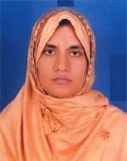 | DR. NILU SHARMIN CHOWDHURY  F/Name: Azizur Rahman Chowdhury  M/Name: Razia Begum  BM & DC Reg. No: 38614  NID: 9329501166005  Cell: 01712259792  Address: Udoy Nagar Road, Dewla, Tangail  Blood Group: O+
169 | Voter No  LM-6600168 | DR. MD. RASHEDUL HASAN  F/Name: M. Manzur Hasan  M/Name: Mrs. Rahima Hasan  BM & DC Reg. No: 37439  NID: 9319559588813  Cell: 01711026014  Address: Vill-Korer Betka, Post-Mirer Betka, Thana+Dist-Tangail  Blood Group: O+
170 | Voter No  LM-6600169 | DR. JAINAB AKTER  F/Name: Md. Jamal Hossain  M/Name: Mrs. Shamsun Nahar  BM & DC Reg. No: 40710  NID: 9329518327892  Cell: 01711018169  Address: Diabetic Hospital Sabalia, Tangail  Blood Group: B+
171 | Voter No  LM-6600170 | DR. SAIFUR RAHMAN KHAN  F/Name: Mafizur Rahman Khan  M/Name: Farida Khanam  BM & DC Reg. No: 34651  NID: 9329518327892  Cell: 01718571047  Address: RMO, General Hospital, Tangail  Blood Group: O+
172 | Voter No  LM-6600171  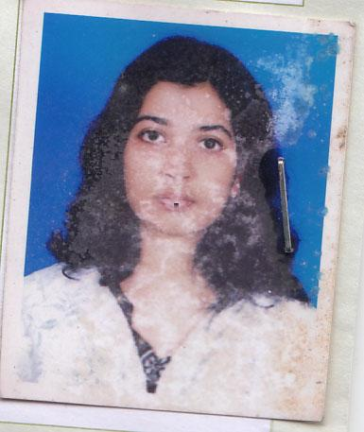 | DR. ANTARA DAS  F/Name: Biman Behari Das  M/Name: Rina Rani Rudra  BM & DC Reg. No: 63134  NID: 8524904042282  Cell: 01734571857  Address: Adalat Road, Tangail  Blood Group: O+
173 | Voter No  LM-6600172 | DR. MD. FAZLUL HAQUE  F/Name: Osim Uddin  M/Name: Rahiton Nessa  BM & DC Reg. No: 20669  NID: 9329516320460  Cell: 01715126308  Address: 6/5, Akur Takur Muslim Para, Tangail  Blood Group: A+
174 | Voter No  LM-6600173 | DR. GAUTOM BOUDDIA PAUL  F/Name: Hari Mohan Paul  M/Name: Kalitara Rani Paul  BM & DC Reg. No: 54350  NID: 2924709173711  Cell: 01836459556  Address: Vill-Patitapara, Post-Patitapara, P.s-Kalihati, Dist-Tangail  Blood Group: O+
175 | Voter No  LM-6600174 | DR. A. K. M. KAMRUZZAMAN  F/Name: Md. Abdul Karim Miah  M/Name: Mrs. Kohinur Khatun  BM & DC Reg. No: 48694  NID: 19831594116722002  Cell: 01717334384  Address: Hospital Quatre, Tangail Medical Collage Hospital, Tangail.  Blood Group: O+
176 | Voter No  LM-6600175  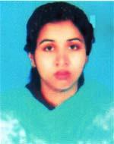 | DR. RUKHSANA YASMIN  F/Name: S. M Rahmatullah  M/Name: Mrs. Salma Rubi  BM & DC Reg. No: 55978  NID:  Cell: 01774233332  Address: Kodalia, Tangail  Blood Group: A+
177 | Voter No  LM-6600176 | DR. TASLIMA AKTER  F/Name: Md. Abu Taher  M/Name: Shirin Akter  BM & DC Reg. No: 62629  NID: 9329517325412  Cell: 01712695548  Address: Vill-Biswas Betka, House No.-26, Block-A/1, Post+Thana+Dist-Tangail  Blood Group: A+
178 | Voter No  LM-6600177 | DR. SANCHITA BHOWMIK  F/Name: Bhabatosh Bhowmik  M/Name: Maya Bhowmik  BM & DC Reg. No: 32553  NID: 19769196203131829  Cell: 01717313568  Address: Upazilla Health Complex, Ghatail, Tangail  Blood Group: B+
179 | Voter No  LM-6600178 | DR. BIPLAB KUMAR PODDER  F/Name: Late Mrinal Kanti Podder  M/Name: Anu Radha Podder  BM & DC Reg. No: 30573  NID: 19739316663779611  Cell: 01712997540  Address: Vill+Post-Jamurki, Mirzapur, Tangail  Blood Group: A+
180 | Voter No  LM-6600179 | DR. MD. LUTFOR RAHAMAN  F/Name: Md. Sohrab Ali  M/Name: Fatema  BM & DC Reg. No: 56061  NID: 2716469409581  Cell: 01731113548  Address: Uttara Residental Area, Post-Ghatail, Upazilla-Ghatail, Dist-Tangail  Blood Group: O+
181 | Voter No  LM-6600180 | DR. CHOWDHURY MOHIWORSHI SIDDIQUE  F/Name: Chowdhury Matiuzzaman Siddique  M/Name: Nargis Akter  BM & DC Reg. No: 57878  NID: 2699501925089  Cell: 01716366839  Address: Zilla Sadar Road, Akur Takur Para, Tangail (FPAB)  Blood Group: A+
182 | Voter No  LM-6600181 | DR. LINKU RANI KAR  F/Name: Late Ahindra Nath Kar  M/Name: Ratna Rani Kar  BM & DC Reg. No: 40715  NID: 19819329516490949  Cell: 01783614170  Address: Akur Takur Para, (Taltola), Tangail  Blood Group: B+
183 | Voter No  LM-6600182 | DR. MONIRA AFROZ  F/Name: Alim Al Razi  M/Name: Sayeda Afroza  BM & DC Reg. No: 57497  NID: 9329504244197  Cell: 01717052978  Address: House No.-613/A, Dighulia, Tangail  Blood Group: A+
184 | Voter No  LM-6600183  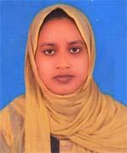 | DR. JASMIN AKTER LIPY  F/Name: Md. Abdul Jalil  M/Name: Mazeda Begum  BM & DC Reg. No: 80619  NID:  Cell: 01822596262  Address: Vill+Post+Thana-Sakhipur, Dist-Tangail  Blood Group: B+
185 | Voter No  LM-6600184  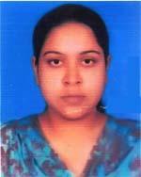 | DR. NOUSHIN ZAHAN AVEE  F/Name: Md. Bellal Hossain Pahlwar  M/Name: Mukta Siddiqua  BM & DC Reg. No: 54635  NID: 6125214283699  Cell: 01717530621  Address: Kumuclinic college road, Tangail  Blood Group: B+
186 | Voter No  LM-6600185 | DR. NISHAT TASNIM MISHU  F/Name: Dr. Md. Mazed Ali Miah  M/Name: Morium Akhter  BM & DC Reg. No: 66470  NID: 19918827810000062  Cell: 01731777437  Address: Akur Takur Para, Housing Estate, Tangail  Blood Group: A+
187 | Voter No  LM-6600186 | DR. MOHAMMAD MASUDUR RAHMAN  F/Name: Md. Moksed Ali Miah  M/Name: Hasna Hena  BM & DC Reg. No: 36070  NID: 2619676108051  Cell: 01711165133  Address: New Bus Stand, Kodalia, Tangail  Blood Group: B+
188 | Voter No  LM-6600187 | DR. MUHAMMAD ABU IDRIS  F/Name: Muhammad Abu Usuf  M/Name: Musanmat Asia Khatun  BM & DC Reg. No: A 42686  NID: 9328503973392  Cell: 01919364027  Address: Address: MO UHC Basil, Tangail. Blood Group: (17)  Blood Group:
189 | Voter No  LM-6600188  No Image | ***NIL***  F/Name:  M/Name:  BM & DC Reg. No:  NID:  Cell:  Address:  Blood Group:
190 | Voter No  LM-6600189 | DR, FARIDA YASMIN ETI  F/Name: Late Kh. Mahbubur Rahman  M/Name: Late Masuda Akhter Helena  BM & DC Reg. No: 35751  NID: 261976107975  Cell: 01716222546  Address: New Busstand, Kodalia, Tangail  Blood Group: O+
191 | Voter No  LM-6600190  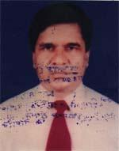 | DR. MD. GOLAM MOSTOFA MIA  F/Name: Late Md. Jamir Uddin Mia  M/Name: Late Rokeya Begum  BM & DC Reg. No: 14674  NID: 9329514305762  Cell: 01711974979  Address: Associate Professor (Surgery) , Tangail, Medical College Hospital  Blood Group: O+
192 | Voter No  LM-6600191  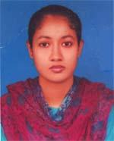 | DR. SAJIA AFRIN  F/Name: Md. Altaf Hossain  M/Name: Shajada Begum  BM & DC Reg. No: 57141  NID: 19869329508265568  Cell: 01729891481  Address: Vill+Post-Santosh, P.s+Dist-Tangail  Blood Group: O+
193 | Voter No  LM-6600192  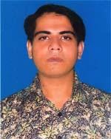 | DR. MD. FORHAD ALI  F/Name: Md. Swakat Ali  M/Name: Morium Begum  BM & DC Reg. No: 40425  NID: 19829329510000011  Cell: 01712013380  Address: Vill-Berai, Post-Kaijury, P.s+Dist-Tangail  Blood Group: B+
194 | Voter No  LM-6600193  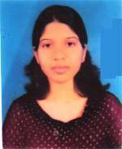 | DR. AKLEMA KHATUN  F/Name: Md. Mostofa Nokib  M/Name: Kamrunnahar  BM & DC Reg. No: 60195  NID: 479817244147  Cell: 01717004770  Address: Vill-Berai, Post-Kaijury, P.s-+Dist-Tangail  Blood Group: A+
195 | Voter No  LM-6600194 | DR. REZUAN AHMED  F/Name: Late Abu Ichaqe  M/Name: Morsheda Rahela  BM & DC Reg. No: 59057  NID: 19869329504219261  Cell: 01711289076  Address: Vill-Pardighulia, Post+P.s-Tangail, Dist-Tangail  Blood Group: B+
196 | Voter No  LM-6600195 | DR. AKLIMA KHAN SUMI  F/Name: Md. Anwar Hossain Khan  M/Name: Mst. Shalina Khanam  BM & DC Reg. No: 72639  NID:  Cell: 01621507782  Address: Vill-Pardighuzia, Post+P.s-Tangail, Dist-Tangail  Blood Group: O+
197 | Voter No  LM-6600196  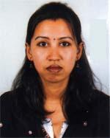 | DR. BANANI BHOWMIK  F/Name: Birendra Mohan Bhowmik  M/Name: Mina Rani Paul  BM & DC Reg. No: 43394  NID: 2697556370654  Cell: 01711462901  Address: Flat # C 3, Saf Glory Associate, Akur Takur Para, Tangail  Blood Group: AB+
198 | Voter No  LM-6600197 | DR. MST. SALMA JAHAN  F/Name: Md. Akkas Ali  M/Name: Gulshan Ara  BM & DC Reg. No: 31024  NID: 9329515311199  Cell: 01715332915  Address: Junior Consaltant Quatar, 250 build, General Hospital, Tangail  Blood Group: B+
199 | Voter No  LM-6600198 | DR. DILIP KUMAR PODDER  F/Name: Monoranjan Podder  M/Name: Geeta Rani Podder  BM & DC Reg. No: 17417  NID: 9329514303089  Cell: 01715626362  Address: East Adalat Para, Tangail  Blood Group: A+
200 | Voter No  LM-6600199  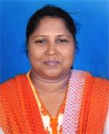 | DR. MT. ALINA KHATUN  F/Name: Late Md. Abu Bakar Siddique  M/Name: Mt. Aleya Begum  BM & DC Reg. No: 28724  NID: 19739329518331065  Cell: 01717798050  Address: House No.-21, Road-4, Block-D, Sabalia, Tangail  Blood Group: O+
201 | Voter No  LM-6600200 | DR. MD. ANOWARUL HOQUE  F/Name: Md. Fazlul Hoque  M/Name: Halima Khatun  BM & DC Reg. No: 34446  NID: 6125214203314  Cell: 01816546260  Address: Shionath Para, Tangail  Blood Group: A+
202 | Voter No  LM-6600201 | DR. SURANJIT KUMER MONDAL  F/Name: Sunil Kumer Mondal  M/Name: Shefali Mondal  BM & DC Reg. No: 42977  NID: 9317673147386  Cell: 01714819256  Address: Vill-Babna Para, Post+P.s-Nagarpur, Dist-Tangail  Blood Group: AB+
203 | Voter No  LM-6600202  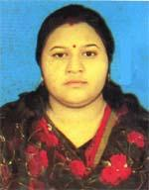 | DR. ESHITA RANI MONDAL  F/Name: Sankar Chandra Mondal  M/Name: Manju Rani Dey  BM & DC Reg. No: 71832  NID: 2617272869242  Cell: 01758204747  Address: Vill-Babnapara, Post+P.s-Nagarpur, Dist-Tangail  Blood Group: O+
204 | Voter No  LM-6600203 | DR. SHAHEENUL ISLAM  F/Name: Md. Habibur Rahman  M/Name: Mrs. Monowara  BM & DC Reg. No: 49430  NID: 9318554877444  Cell: 01731710150  Address: Purba Adalat Para, Tangail Sadar, Tangail  Blood Group: B+
205 | Voter No  LM-6600204 | DR. MD. ALI HOSSAIN  F/Name: Late Md. Badsha Miah  M/Name: Mrs. Awzia Begum  BM & DC Reg. No: 46227  NID: 19832694266786357  Cell: 01830450040  Address: Vill-Vobanipur Patuli, Post-Kagmari, Thana & Dist-Tangail  Blood Group: O+
206 | Voter No  LM-6600205 | DR. ISHRAT ZAHAN RUNA  F/Name: Md. Nurul Islam  M/Name: Mrs. Firoza Akter  BM & DC Reg. No: 42450  NID: 9319537456015  Cell: 01715660692  Address: Polashtoli, Tangail  Blood Group: A+
207 | Voter No  LM-6600206 | DR. AMINUL ISLAM  F/Name: Mohammed Idris Ali  M/Name: Mrs. Nasima Begum  BM & DC Reg. No: 44156  NID: 9329514208249  Cell: 01720019986  Address: Shrity Kanon, Upazilla Road, East Adalot Para, Tangail  Blood Group: B+
208 | Voter No  LM-6600207  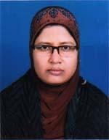 | DR. TAHURA TAJ LAIZU  F/Name: Md. Taizuddin  M/Name: Rabeya Begum  BM & DC Reg. No: 30313  NID: 2699040723803  Cell: 01914178503  Address: Vill-Kodalia, Post+P.s+Dist-Tangail  Blood Group: O+
209 | Voter No  LM-6600208  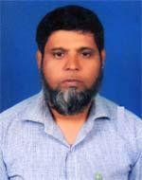 | DR. MD. MASUD MURSHED TALUKDER  F/Name: Md. Sanowar Hossain Talukder  M/Name: Mrs. Shamsun Nahar  BM & DC Reg. No: 24380  NID: 9329518333936  Cell: 01712553000  Address: Vill-Kodalia, Post+P.s+Dist-Tangail  Blood Group: A+
210 | Voter No  LM-6600209 | DR. MD. MARUF AHMED MOLLA  F/Name: Md. Arfan Ali Molla  M/Name: Farida Afrin  BM & DC Reg. No: 63357  NID: 19879329516317472  Cell: 01711447858  Address: House No.-63, Block-E, Akur Takur Muslim Para, Tangail  Blood Group: O+
211 | Voter No  LM-6600210 | DR. JANNAT ARA DISHA  F/Name: Md. Juglul Alam  M/Name: Asma Alam  BM & DC Reg. No: 73238  NID: 19910695112000022  Cell: 01775939079  Address: House-63, Block-E, Akur Takkur, Muslim Para, Tangail  Blood Group: O+
212 | Voter No  LM-6600211 | DR. RABBY ISLAM  F/Name: Md. Sirajul Islam  M/Name: Parvin Sultana  BM & DC Reg. No: 65657  NID: 4798516226922  Cell: 01717564194  Address: Holding-0172-06, Bokultoli, Akur Takur Para, Tangail  Blood Group: B+
213 | Voter No  LM-6600212 | DR. SHUBHENDU CHAKRABORTY  F/Name: Dr. Shambhu Nath Chakraborty  M/Name: Prity Kana Chakraborty  BM & DC Reg. No: 62378  NID: 19889329513000006  Cell: 01718300868  Address: Flat # B1, House # 366, Six Anna's Bazar, Tangail  Blood Group: A+
214 | Voter No  LM-6600213 | DR. MD. RIFAT HASAN  F/Name: Md. Hazrat Ali  M/Name: Sheria Begum  BM & DC Reg. No: 61971  NID: 9329516319921  Cell: 01911537312  Address: Choto Kali Bari, Akur Takur Para, Tangail  Blood Group: O+
215 | Voter No  LM-6600214 | DR. MD. ASSADUZZAMAN LITON  F/Name: Md. Ibrahim Khalil  M/Name: Anwara Begum  BM & DC Reg. No: 51466  NID: 9329516316889  Cell: 01748975226  Address: Room-E-7, Doctor's Dornitory Dhaka Medical College Hospital, Dhaka.  Blood Group: A+
216 | Voter No  LM-6600215 | DR. SANCHITA MAITRA  F/Name: Shujit Kumar Maitra  M/Name: Smrity Kana Maitra  BM & DC Reg. No: 42171  NID: 9329513300680  Cell: 01715234803  Address: Adalat Para, Kalibari Road,Post+Dist-Tangail  Blood Group: AB+
217 | Voter No  LM-6600216 | DR. SHIRLY HAMID  F/Name: Mohammad Hamidullah  M/Name: Sufia Khandader  BM & DC Reg. No: 46776  NID: 9329518330984  Cell: 01914554630  Address: Shawpna Nir, Diabetic Hospital Road, Sabara, Tangail  Blood Group: AB+
218 | Voter No  LM-6600217 | DR. MOHAMMAD AZIZUL HAQUE  F/Name: Md. Hossain Ali  M/Name: Rang Mala Begum  BM & DC Reg. No: 51369  NID: 612517227638  Cell: 01912972673  Address: Doctor\'s Dormitory, General Hospital, Tangail  Blood Group: A+
219 | Voter No  LM-6600218  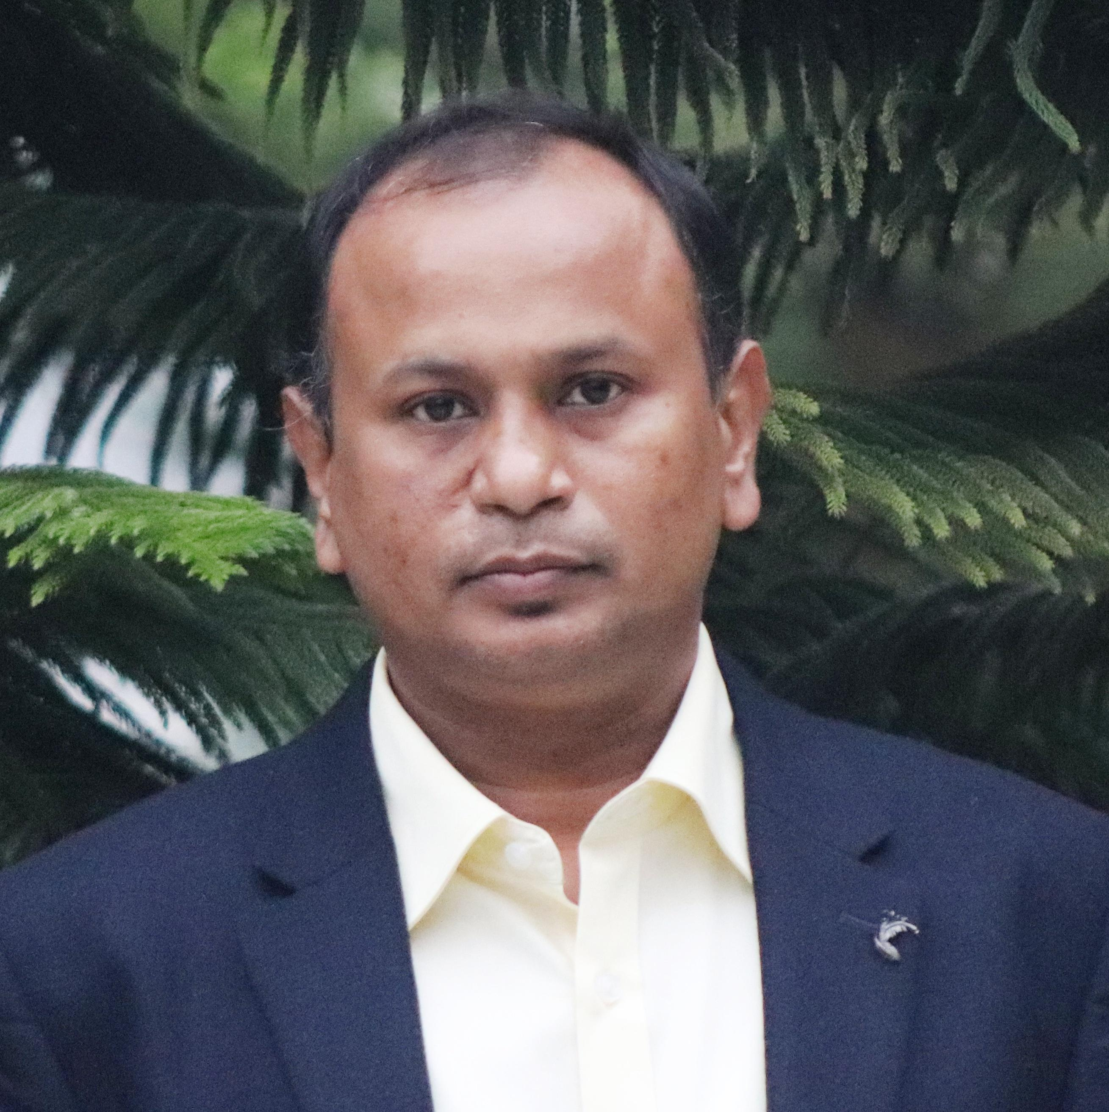 | DR. PRANOB KARMAKER  F/Name: Gour Chandra Kamaker  M/Name: Bina Rani Karmaker  BM & DC Reg. No: 38471  NID: 19809319559566913  Cell: 01711302800  Address: Senior Consultant (Cardiology), 250 Bedded General Hospital, Tangail.  Blood Group: A+
220 | Voter No  LM-6600219 | DR. D. I. REZAUL KARIM  F/Name: Late Ahsan Uddin  M/Name: Late Moziron Nessa  BM & DC Reg. No: 11874  NID: 19579385098  Cell: 01718172244  Address: Dhaka Rd, Sakhipur, Tangail  Blood Group: AB+
221 | Voter No  LM-6600220 | DR. ABEDA SHAMIM  F/Name: Late M. Abul Khair  M/Name: Taslima Khair  BM & DC Reg. No: 44981  NID: 9329513300437  Cell: 01711079997  Address: H-738, Bajitpur Road, Tangail. Mohalla, Tangail Sadar, Tangail  Blood Group: A+
222 | Voter No  LM-6600221  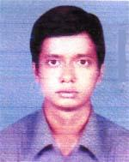 | DR. MOHAMMAD KAMRUL ISLAM  F/Name: Mohammad Sirazul Islam  M/Name: Rebeka Sultana  BM & DC Reg. No: 40996  NID: 9314787272318  Cell: 01915415865  Address: House No.-2/6, Flat No.-6B, Habibullah road , Shahbag, Dhaka  Blood Group: A+
223 | Voter No  LM-6600222  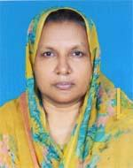 | DR. KAMRUN NAHAR BEGUM  F/Name: Md. Siddiquer Rahman  M/Name: Mrs. Shamsun Nahar Begum  BM & DC Reg. No: 19861  NID: 9323808994736  Cell: 01716531038  Address: Upazilla Health Complex, Nagarpur, Tangail  Blood Group: A+
224 | Voter No  LM-6600223 | DR. PIA ROY  F/Name: Kiron Kumar Roy  M/Name: Anita Roy  BM & DC Reg. No: 42172  NID: 2699038643107  Cell: 01717453968  Address: Purba Adalat Para, Tangail  Blood Group: AB+
225 | Voter No  LM-6600224 | DR. MOHAMMAD SHAHARIAR SAJJAD  F/Name: Zafer Sadque  M/Name: Siddika Sadque  BM & DC Reg. No: 31466  NID: 3323004135351  Cell: 01744292943  Address: C-3, Primio Plaza, Akur Takur Para, Bottola, Tangail  Blood Group: O+
226 | Voter No  LM-6600225 | DR. MD. ALAUDDIN  F/Name: Md. Aftab Uddin  M/Name: Mrs. Anowara Begum  BM & DC Reg. No: 25629  NID: 2694069202145  Cell: 01717562195  Address: Ju. Consultant, Samtosh, Tangail  Blood Group: B+
227 | Voter No  LM-6600226 | DR. MST. AHSANA AKTER  F/Name: Md. Altaf Hossen Sarker  M/Name: Saleha Begum  BM & DC Reg. No: 31463  NID: 8524901009251  Cell: 01824615915  Address: C-3, Premio Plazza, Bottola, Akur Takur Para, Tangail  Blood Group: O+
228 | Voter No  LM-6600227 | DR. KAWSER JAHAN  F/Name: Md. Abu Kaiser Molla  M/Name: Selina Sayeed  BM & DC Reg. No: 41324  NID: 9329503216065  Cell: 01729964234  Address: 101, West Akur Takur Para, Tangail  Blood Group: A+
229 | Voter No  LM-6600228 | DR. BARNALI DAS  F/Name: Late Deba Brata Das  M/Name: Kabita Das  BM & DC Reg. No: 46939  NID: 2694812094125  Cell: 01712240494  Address: Upazilla Health Complex, Mirzapur, Tangail  Blood Group: AB+
230 | Voter No  LM-6600229 | DR. MOHD. NAZMUL HOSSAIN  F/Name: Dr. Md. Mosharrof Hossain  M/Name: Nazma Monowara  BM & DC Reg. No: 60546  NID: 4820606426993  Cell: 01711171871  Address: Madhupur Consultattion Center & Diagnostic, Madhupur, Tangail  Blood Group: O+
231 | Voter No  LM-6600230 | DR. DIBASH BANARJEE  F/Name: Mr. Shyamal Banarjee  M/Name: Mrs. Bina Banarjee  BM & DC Reg. No: 57198  NID: 9329517323037  Cell: 01716045149  Address: Palash tali, Tangail, Block-C, House No.-24/6  Blood Group: B+
232 | Voter No  LM-6600231 | DR. NASRIN SULTANA  F/Name: Md. Abul Hashem Molla  M/Name: Laila Parvin  BM & DC Reg. No: 52674  NID: 4794508103389  Cell: 01737434318  Address: West Akur Takur Para, Tangail  Blood Group: O+
233 | Voter No  LM-6600232 | DR. MD. ASHAQ ALI  F/Name: Md. Abed Ali  M/Name: Late Mrs. Hajeza Khatun  BM & DC Reg. No: 35620  NID: 9329516316321  Cell: 01715404755  Address: 8B, Labu Chowdhury Premio Plasa Battalla, Akur Takkur Para, Tangail  Blood Group: O+
234 | Voter No  LM-6600233 | DR. TAHMINA SULTANA  F/Name: Kh. Nazrul Islam  M/Name: Taslima Sultana  BM & DC Reg. No: 65478  NID: 9329517323869  Cell: 01711908919  Address: B.B. Govt. Girl's School Road, Akur Takur Para, Boropukurpar, Tangail  Blood Group: O-
235 | Voter No  LM-6600234 | DR. SAYDA SONIA ISLAM  F/Name: Sayed Rofiqul Islam  M/Name: Sayda Shahin Akter  BM & DC Reg. No: 54540  NID: 9319787279576  Cell: 01725063544  Address: Sabalia, Battala, Tangail  Blood Group: O+
236 | Voter No  LM-6600235  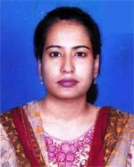 | DR. IRIN ZAMAN  F/Name: Md. Ashrafuzzaman  M/Name: Mirza Fahmida Zaman  BM & DC Reg. No: 55271  NID: 9329503204301  Cell: 01753810396  Address: 101/2, Block-A, Paradaise Para, Tangail  Blood Group: B+
237 | Voter No  LM-6600236 | DR. MOHAMMAD SAIFUL ISLAM MIAH  F/Name: Late Riaz Uddin Miah  M/Name: Samola Begum  BM & DC Reg. No: 40892  NID: 9310911145652  Cell: 01711978705  Address: Sheba Clinic, Paraton bus stand, Tangail  Blood Group: AB+
238 | Voter No  LM-6600237 | DR. RAFIUL KARIM KHAN  F/Name: Abdul Karim Khan  M/Name: Kaniz Fatema  BM & DC Reg. No: 27896  NID: 2691651203153  Cell: 01944225270  Address: Upazilla Health Complex, Shakhipur, Tangail  Blood Group: A+
239 | Voter No  LM-6600238 | DR. MOHAMMAD IBRAHIM  F/Name: Motiar Rahman  M/Name: Mrs. Rezia Khatun  BM & DC Reg. No: 52803  NID: 19799319559000057  Cell: 01748861838  Address: Vill-Dhulotia, Post-Pathrail, P.s-Tangail, Dist-Tangail  Blood Group: B+
240 | Voter No  LM-6600239 | DR. NAZMUL HOSSAIN  F/Name: Md. Liaquat Ali  M/Name: Late Fatiha Begum  BM & DC Reg. No: 31664  NID: 9328507982238  Cell: 01711261854  Address: UHC, Sakhipur, Tangail  Blood Group: A+
241 | Voter No  LM-6600240 | DR. SHAMIMA AHMED  F/Name: Shafy Uddin Ahmed  M/Name: Aleya Ahmed  BM & DC Reg. No: 45315  NID: 9328507982239  Cell: 01712595320  Address: MO, Hatibandha Sub-Centre, Sakhipur, Tangail  Blood Group: A+
242 | Voter No  LM-6600241  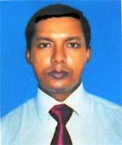 | DR. MD. SHAMIUL ISLAM  F/Name: Md. Rostam Ali  M/Name: Saleha Begum  BM & DC Reg. No: 36827  NID: 9429401103267  Cell: 01723402022  Address: Sakhipur Upazilla Health Complex, Tangail  Blood Group: A+
243 | Voter No  LM-6600242 | DR. MD. SHAFIQUL ISLAM  F/Name: Md. Abdus Salam  M/Name: Shirina Begum  BM & DC Reg. No: 63912  NID: 9329504245752  Cell: 01760879414  Address: Dormitory, Upazilla Health Complex, Sakhipur, Tangail  Blood Group: B+
244 | Voter No  LM-6600243 | DR. PRAFULLA KUMAR SAHA  F/Name: Pramath Nath Saha  M/Name: Ashalata Saha  BM & DC Reg. No: 15630  NID: 9322808546563  Cell: 01199089146  Address: UH & FPO, Upazilla Health Complex Madhupur, Tangail.  Blood Group: A+
245 | Voter No  LM-6600244 | DR. MD. TARIQUL ISLAM  F/Name: Md. Moslem Uddin  M/Name: Ms. Rabea Begum  BM & DC Reg. No: 50661  NID: 9315766250743  Cell: 01790395487  Address: Docts Quater, U.H.C. Madhupur  Blood Group: B+
246 | Voter No  LM-6600245 | DR. MD. MOFIJUL ISLAM BULBUL  F/Name: M. A. Awal  M/Name: Mrs. Morzina Begum  BM & DC Reg. No: 55570  NID: 6125217227676  Cell: 01717449219  Address: Flat-C7, Rangs Hafiz Tower, 65-66, Shiddheswary Road, Ramna, Dhaka  Blood Group: B+
247 | Voter No  LM-6600246 | DR. MD. RIFAT HASSAN  F/Name: Md. Rafiqul Islam Mia  M/Name: Hamida Khatun  BM & DC Reg. No: 67642  NID: 19899329518330646  Cell: 01716577886  Address: H. No.-336/KA, Road-8, Block-E, Sabalia, Tangail  Blood Group: B+
248 | Voter No  LM-6600247 | DR. SABRINA AFROZ  F/Name: Saleh Ahmmed Akbar  M/Name: Sahida Akter  BM & DC Reg. No: 67644  NID: 19893313067000363  Cell: 01739976099  Address: Holding No.-336/KA, Road-8, Block-E, Sabalia, Tangail  Blood Group: A+
249 | Voter No  LM-6600248 | DR. FATEMA TUZ ZOHRA  F/Name: Nur Mohammad  M/Name: Salma Begum  BM & DC Reg. No: 72747  NID: 19929329503000095  Cell: 01717212900  Address: D-36, West Akur Takur Para, Tangail  Blood Group: AB+
250 | Voter No  LM-6600249  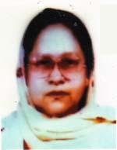 | DR. SHEFALI KHATUN  F/Name: Md. Mohiuddin  M/Name: Rabeya Khatun  BM & DC Reg. No: 16105  NID: 9319565360662  Cell: 01710892427  Address: UHC, Basail, Tangail  Blood Group: B+

